**Lesson 6 Demo 4**

**How to Create Pareto Chart**



**Steps to be followed:**

**Step 1: Open the Excel file**

* 1. Open the file named **Chart.xlsx** and click on the **Pareto Chart** worksheet

**Step 2: Create a chart**

2.1 Customer Complaints and Frequency data on the table

2.2 In the Insert tab, choose Clustered Column chart for the data

2.3 The chart will look like this

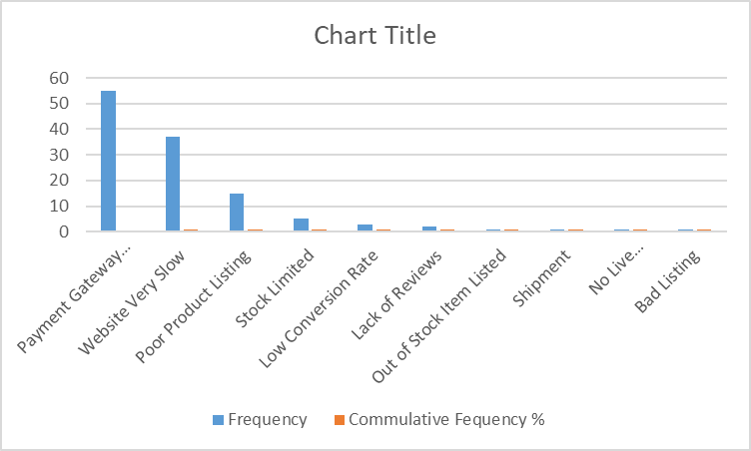

2.4 Click on the chart and choose **Series “Cumulative Frequency %”** in the drop-down

2.5 In the Format Data Series box, change the axis to Secondary Axis

2.6 Now, the chart will look like this

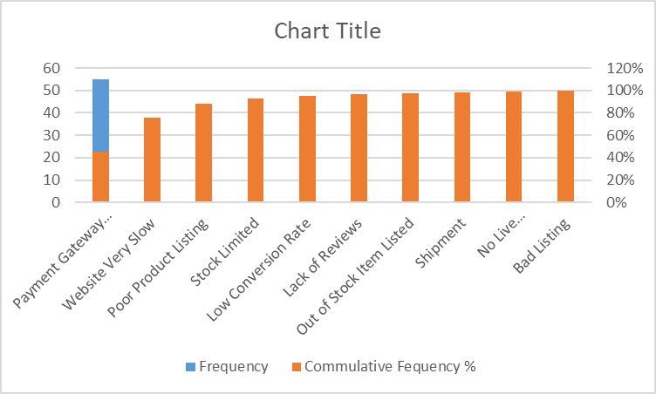

2.7 Right-click on the chart and choose Change Chart Type

2.8 In the Combo chart, change the Cumulative Frequency % to Line graph

2.9 The final Pareto chart will look like this

